1. What is Git?
Git is a version control system (VCS) used to track changes in source code and manage different versions of a project.
It helps developers:
- Track code changes
- Go back to previous versions
- Collaborate with other developers

2. What is GitHub?
GitHub is a cloud platform for hosting Git repositories and managing different versions of project

3. What is the difference between Git and GitHub?
This is one of the most frequently asked questions.
Git | GitHub
Version control system(software) | It is a platform where git is embedded into it

4. What is a Git repository?
A Git repository (repo) is like a folder where all the project's files and its version history is stored.

5. What is the difference between Working Directory, Staging Area, and Repository?
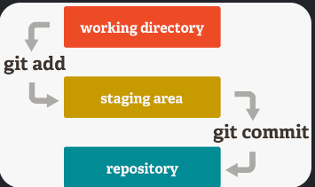
A. Working Directory
The working directory is the actual project folder where you create and modify files.
B. Staging Area
The staging area contains files that you have selected and ready to move into repository.
C. Repository
After staging, you create a commit:

7. What are git add, git commit, and git push?
git add
Moves changes from the working directory to the staging area.
git commit
Moves staged changes into the local Git repository history.
git push
Uploads local commits to a remote repository, such as GitHub.

8. What is git clone?
git clone is used to create a local copy of an existing remote repository.
It downloads the repository to your computer.

9. What is git pull?
git pull is used to download the remote repository and integrate them into your current local branch in your system

10. Difference between git pull and git fetch?
This is another very common interview question.
git fetch
Downloads the remote repository without integrating them into your current branch.
Main difference
git fetch | git pull
Downloads remote changes | Downloads remote changes
Does not integrate them into current branch | Integrates them into current branch

4. What is a merge conflict and how do you resolve it?
A merge conflict occurs when a file is modified differently by different developers and git cannot handle their changes
We resolve it manually, stage the resolved files, and complete the merge.

8. What is .gitignore and why is it important?
.gitignore is a file that tells Git which files or directories should not be tracked or pushed into git system

3. What is a remote repository?
A remote repository is a Git repository stored in GitHub.

6. What is a fork in GitHub?
A fork is a mechanism used to create your own copy of someone else's GitHub repository under your GitHub account.

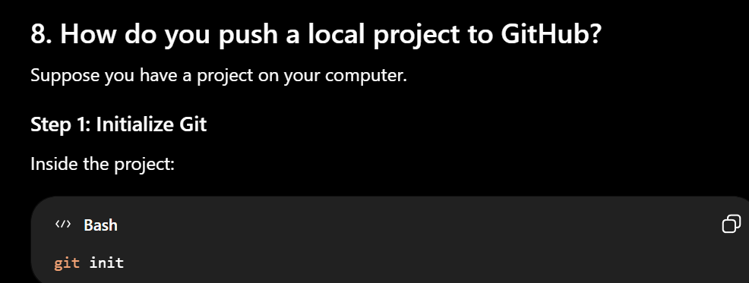
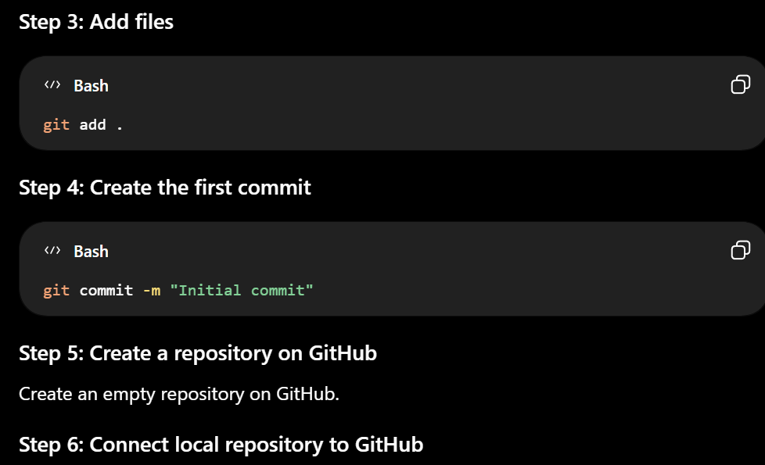

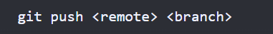
9. How do multiple developers collaborate using GitHub?
Developers usually work on separate branches, push their changes to GitHub

10. What is GitHub Actions?
GitHub Actions is a tool used to implement CI/CD.

11. What is CI/CD?
CI/CD stands for Continuous Integration and Continuous Delivery/Deployment.
CI — Continuous Integration
Developers works on separate branches and integrate their code into a shared repository.
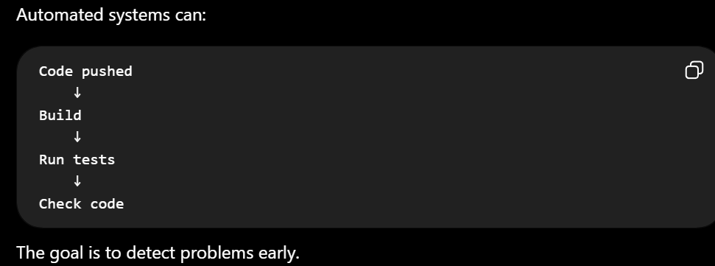
CD — Continuous Delivery / Deployment
After code passes the required checks, it can be prepared for or automatically deployed into an environment.

12. How do you protect API keys and passwords in GitHub?
use: Environment variables
and add .env to .gitignore

13. What should you do if you accidentally push an API key to GitHub?
Delete the exposed key from github
Generate a new key and disable the old one.

14. What is a README file?
A README is a documentation file that explains a project.
Project name
Description
Features
Tech stack

15. Public vs Private GitHub Repository?
Public repository
A public repository can be viewed by anyone on the internet,
Private repository
A private repository is restricted to the owner and explicitly authorized collaborators/teams.

